https://developer.bluetooth.org/Pages/Bluetooth-Android-Developers.aspx

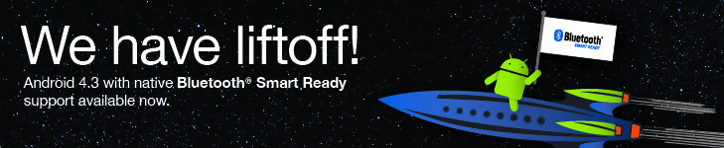

​Your Life Just Got Simpler
Developing for Bluetooth®​ Smart technology is now easier than ever. Android 4.3 joins all major operating systems now providing native support for Bluetooth Smart. Hardware and software developers of Android-powered devices and applications can now write apps to a single Bluetooth API included in the latest Android SDK. This opportunity starts with the new Nexus 7 and Nexus 4 - among the first of a growing number of Android compatible devices to support Bluetooth Smart technology.

It Gets Even Better
To help assist your development efforts the Bluetooth introduces the application accelerator. This tool is designed to cut time-to-market and save valuable resources by providing everything you need to quickly build a Bluetooth Smart application across Android 4.3, iOS, OSX and Windows 8 OS platforms.
New innovation and revenue opportunities are now available across many verticals—sports and fitness, medical, smart home, consumer electronics and more. With Bluetooth Smart and the application accelerator, you can capture the imagination of consumers worldwide with accessories and applications that make life better, give more insight and help make better decisions.
Bluetooth Smart isn’t just a wireless protocol, it’s a developer’s platform. It offers low power, low cost, a smaller footprint and high security. Unleash your creativity to do amazing things.
​
Take the first step. Complete the form to download the free application accelerator today.
(Prior to downloading, please review the end user licensing agreement)

Bluetooth Smart Technology — Creating Enormous Market Potential
- Bluetooth enabled appcessories are projected to experience massive growth—220 million units this year to nearly 1 billion per year by 2016 (ABI Research)
- Bluetooth technology connects virtually anything. There are billions of devices already in the world (and growing!), creating endless development possibilities
- Virtually limitless market for application developers with Bluetooth technology as an open platform, global standard and ubiquitous device ecosystem
- All major operating systems now support Bluetooth technology including the Android ecosystem so you can easily expand your market
© 2014 Bluetooth SIG, Inc. All rights reserved.

