RJ45 with integrated Transformer and connected CT
For using connected CT signals inside the Transformer or inside RJ45 the matching network (2x 82R) of the RX+/- signals must be isolated from CT (3.3V).
Please refer to the following schematic:
- C23 and C24 must be added. Otherwise, W5500 won't operate well.
- And by connected center tap, Power dissipation may be raised.
- So, you'd better use a MAGJACK without connected center tap except the case that you have to use one with connected center tap.
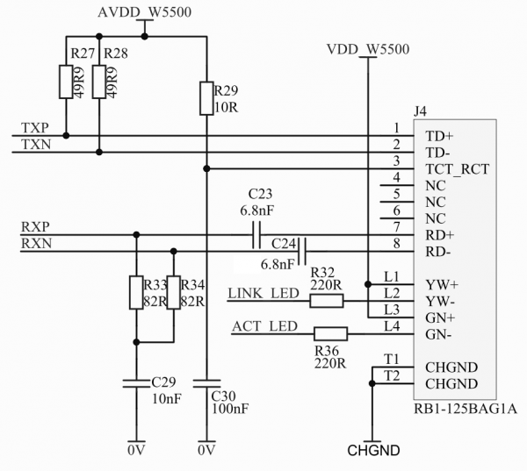

Recommended RJ45 using W5500

External Transformer
- H1102NL from Pulse datasheet
- LCZ3A1CB from CETUS datasheet

RJ45 with integrated Transformer
- J1B121ZCCD from CETUS datasheet
- J1B1211CCD from CETUS datasheet
- RB1-1D5B8K1A from UDE datasheet
- J0011D21BNL from Pulse datasheet

